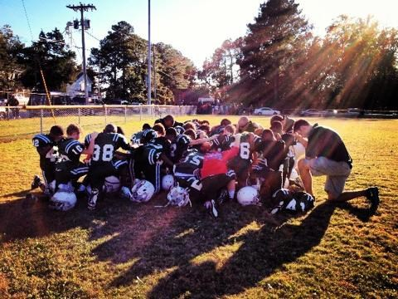
2019

Monday, July 16th - Friday, July 19th 9:00am - 12:00pm
JH Rose High School
600 W. Arlington Blvd
2019 SEASON REGISTRATION
ONLINE :
www.pittgreenvilletitanyouthfootball.com OR
Monday, July 15th - Friday, July 19th
6:00pm - 7:00pm
Boyd Lee Park

Hosted by

FOR MORE INFORMATION: (252) 801-6305
www.pittgreenvilletitanyouthfootball.com

